## Practice Activity 3

Name: Zahida

Mail id: zahidajmi1809@gmail.com

## Summary

**1. Interactive vs. Non-Interactive Applications**

* Interactive apps require user input and display windows (e.g., browsers, installers).
* Non-interactive apps run silently in the background without user interaction (e.g., update checkers).

**2. IntuneWin Conversion for Win32 Apps**

* Collect all installer files (.exe, .msi, etc.).
* Use Microsoft’s IntuneWinAppUtil.exe tool to create a .intunewin package.
* Upload this package to Intune and configure silent install/uninstall commands.
* Apps must be under 8 GB and run on Windows 10 (version 1607+) enrolled devices.

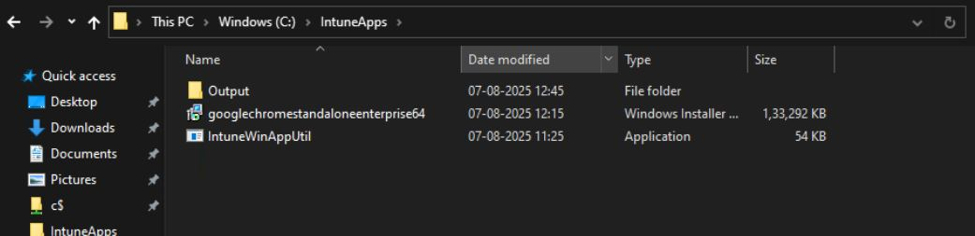

**3. Intune Management Extension (IME) Deployment Flow**

* Devices poll Intune for new apps/policies.
* IME checks if apps are installed via detection rules (files, registry, MSI codes).
* If missing, IME downloads and silently installs the app.
* Installation success is verified and reported back.
* User notifications and possible restarts complete the process.

**4. Registry Role in LOB and Win32 Apps**

* The Windows Registry stores app settings, install status, and preferences.
* Intune uses registry keys to detect app presence and version.
* Registry changes can configure apps but must be done carefully to avoid issues.